Jesus ‘H’ Christ, The Son of God, pictured prior to the horrendous attack….

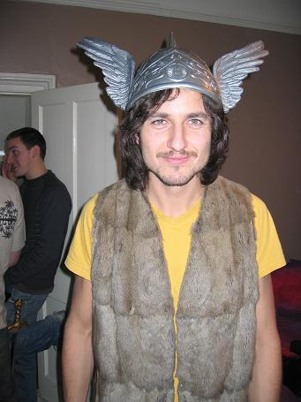

Beelzebub himself (AKA Tarquin ‘The Hero’ Hellier), here wearing Japanese Party Suit, strikes down Jesus…

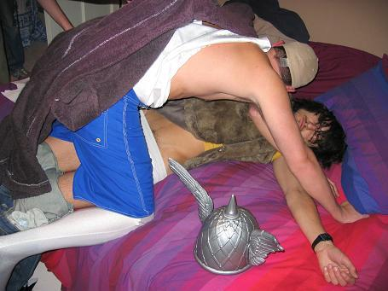

Jesus seen shortly after the attack. It is rumoured he once more rose from the dead in the Garden of Effra…

